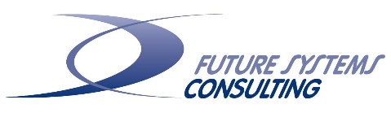
Executive Guides for
Breakthrough Performance

Andy Hass
Richard Bents
St. Paul Minnesota USA
February 2018

Executive Guides are short introductions to very large concepts of leadership. The Executive Guide is a succinct (five to fifteen page) document created to provide a quick understanding of the foundations of Breakthrough Performance. Enjoy this quick overview.

Visit WeMeasureTrust.com to participate in our TRUST research in collaboration with the University of Minnesota, University of Wyoming and European partners (Aquilone, Art of Progress, Blank Consulting) or receive more information on our trust conferences (Budapest 2019, St. Paul 2020, Hamburg 2021).

Trust

Point 1 – Disturbing Data: “Fifty-eight percent (58%) of CEOs think that a lack of trust is a threat to their organization’s growth. But most have done little to increase trust, mainly because they aren’t sure where to start” according to a survey reported by PWC ‘Redefining business success in a changing world CEO Survey.’ The survey additionally states, “The impact on CEOs has been significant: in 2013, 37% worried that lack of trust in business would harm their company’s growth. This year, the number has jumped to 58%. The breakdown in public trust now poses a potent risk to political, economic and social systems the world over.” Lastly, roughly half of all managers don’t trust their leaders according to a recent Harvard Business Review article by Robert Hurley.

Trust levels are clearly not what we would like them to be in most organizations. This is true in the entire world as well. Leaders do not trust other leaders, regions homogenize and do not trust those that are different, countries withhold trust from other countries, and all find it difficult to even discuss where to start.

Point 2 – Higher Trust = Success: Trust plays an important role in success – any success. How important? “Compared with people at low-trust companies, people at high-trust companies report:
- 50% higher productivity
- 106% more energy at work
- 76% more engagement
- 74% less stress
- 13% fewer sick days
- 29% more satisfaction with their lives
- 40% less burnout.”
(Paul Zak in ‘The Neuroscience of Trust’ by Paul Zak in Organizational Culture January-February 2017)

Further, Covey (2006) argued that trust has become the key leadership competency of the new global economy. In this context, Covey offers a simple formula for the benefits of trust and the frightening damage of distrust: “When trust goes up, speed will also go up and the costs will go down.” Conversely, “When trust goes down, speed goes down and costs go up.” It is just that simple.

In Google’s study by their People’s Analytics Department study on what made an effective team (Project Aristotle), they identified 180 teams and used over 35 different statistical models on hundreds of variables, and found the best predictor of high performance was trust – not talent, not diversity, not experience, not strategy.

Studies by Szobonya (2014) demonstrated that by increasing trust in self and trusting others, profits and market share grew significantly, and Bents (2015) in a similar study reported significant increases in employee satisfaction and employee engagement.

Point 3 - Self Trust is Critical to Elevating our Leadership Potential:
Trust is important because it allows us to have confidence in self, in our knowledge of self, in our authenticity. It is important as we form relationships with ourselves. We need self-trust to remain sane. Trust in self is necessary for authenticity. We need to trust ourselves in order to be able to trust others as we depend on them - for advice, for love, for help with our plumbing, or what have you - especially when we know that no outside force or law compels others to give us such things. Therefore, first focus on self-trust, experience trust resonating with your-self, then extend that trust to engage in trusting relationships with others. Know the trust resonating within and among others.

Focusing on self-trust, high trust individuals will exude benevolence, integrity, and the ability to get things done. According to recent research by Jones and Shah (2015), and our collaboration partners in current research, benevolence and integrity are two key factors which potential trustors seek when establishing trust relationships – these are clear keys for successful trust-building leadership. The perception of having the ability to create the necessary and appropriate actions also plays heavily into trustworthiness and with whom trust is placed. Leaders, take note: First, do you believe that you have these qualities and secondly; do you exude them clearly to create the right perceptions for those that you are leading?

Point 4 - Neuroscientists have identified “The Trust Molecule” – Oxytocin: We now know that oxytocin, a human peptide hormone, and neurotransmitter in the brain, increases trust and that some activities will enhance, while other activities will inhibit the natural production of oxytocin. For example, recognizing excellence, giving people discretion in how they do their work, enabling job crafting, sharing information broadly, intentionally building relationships, facilitating whole-person growth, and showing vulnerability all enhance the natural production of oxytocin within your body. Conversely, any action or activity that produces high stress levels inhibits the production of oxytocin.

Further studies by Zak (2017) on the neuroscience of trust and the role of oxytocin, indicates it reduces the fear of trusting a stranger – it plays a clear role in social bonding – in all human bonding. It is universal.

With this knowledge we suggest:
- “High stress is a potent oxytocin inhibitor”, therefore monitor levels of stress
- “Oxytocin increases a person’s empathy”, therefore mobilize resonant trust (described later)
- “The relationship between oxytocin and trust is universal”, therefore creating trust can be done in any and all cultures.

Point 4a - Monitor levels of stress. From the Mayo Clinic, “Your body's stress reaction was meant to protect you. Stress is a normal psychological and physical reaction to the demands of life. However when you're unable to cope well with the stress in your life, your mind and body may pay the price. Your body is hard-wired by nature to react to stress in a way originally meant to protect you against perceived threats from predators and aggressors. Today's many demands may include managing a huge workload, making ends meet, taking care of aging parents as well as young children, and simply making it through the morning rush hour. You may feel overwhelmed by these daily stressors and wonder if you'll ever get a handle on all of these extra "threats" — you can empower yourself to do so.”

As a leader, even if you’re feeling stress and pressure for trying to meet challenging goals and deadlines, you are not doing your team any favors by passing along your stress. Under constant stress our brains simply reiterate and reinforce old patterns and are not open to new, innovative, or unexplored ideas. Further, our bodies become at risk for numerous health problems and push closer to extreme or uncontrolled stress (Hüther).

A better way to handle constant stress or that feeling of being overwhelmed would be to:
- Look inward and take care of yourself in mind, body and spirit: Exercise, eat well, get enough sleep, challenge your mind (read, do something creative, meditate), engage in spirituality or “your deepest values by which you live by” (religion, rituals, community, relationships, energy, etc.).
- Don’t ignore the fact that employees are overwhelmed. Acknowledge it with respect. Tell them: “I know you’re swamped. We’ve got a lot going on.”
- Express appreciation. A simple “thank you” for going the extra mile can defuse a lot of the feelings that work is overwhelming. Someone who feels appreciated might be less resentful, and more willing to make personal sacrifices to help the company get through a hard time.
- Build an even more collaborative environment. Encourage managers and employees to help each other and work together to get essential and top priorities done. Build a “we’re all in this together” culture.
- Be consistently clear about priorities. Encourage regular instructions from managers to staff. Managers can help by setting priorities. Employees will feel less like it’s all up to them — and less guilty when they can’t get it all done by themselves. Honor and respect the fact that people are feeling overwhelmed, and those employees will more likely accept it as the new normal — and acknowledge that they can get important work done.
- Listen and coach. Allow employees to honestly express their feelings. Give them time to vent, and then help them develop a plan. That will go a long way to defusing hard feelings and low productivity caused by feeling overwhelmed. It will help employees gain control of their own work.
(Hass, Bents, Corley)

Point 4b - Mobilize resonant trust. Trust is not blind confidence or faith. Trust is always created in context and always has various elements of analysis. Covey suggests that their needs to be an alignment of equal measure of analysis with the propensity to trust. When the propensity to trust is high and there is no analysis the result is gullibility. When the propensity to trust is very low and analysis is very high suspicion results. When both propensity to trust and analysis are very low there is indecision. Therefore, when the propensity to trust is in equal measure to analysis, resonant trust is exercised.

When deciding to trust or not to trust, Hurley (2006) suggested a review of levels of decision maker factors and situational factors all rated on a scale from low to high. Decision maker factors include risk tolerance, how well-adjusted the decision-maker is, and how much relative power he/she has. Situational factors include: how secure the parties feel, how many similarities exist between the parties, how well aligned their interests are, does the trustee show benevolent concern, is the trustee capable, has the trustee shown predictability and integrity, and do the parties have good communication.

Point 4c - Creating trust can be done in any and all cultures. In a diverse and globalized world trust plays a major role. Individuals, organizations, and even regions and countries are challenged when confronted by someone or something different. How do we assist in productive performance when differences abound? We are all human, we all are affected by oxytocin in the same ways. We all come to the table with our own unique experience based on many different factors that help to shape us as human beings. How do we ensure higher levels of oxytocin? We know for example that “trust is formed when an organization shows commitment to diversity by alleviating employees’ fear of being judged or ridiculed because of cultural or personal differences” (Shelton, 2017). This is likely a good start.

Two key points here: 1) every human has something in common with every other human. Focus on what we have in common; 2) every human is different from every other human. Build trust (using what is common) to build bridges and celebrate differences. Not easy, however doable. To quote Steve Young; “It is in this commonality and diversity that we find appropriate intersections upon which to build foundations for future human growth and fruition.”

Point 5 - Trust in Others is Necessary for Responsible Action: Trust is the adhesive that holds us in community. It identifies and guides our responsibilities. We are in relationship. We rely on trust. Currently the participatory nature of reality has focused scientific attention on relationships and necessary trust. We all are in relation. We are all connected. It is through relationship and participation that we are nurtured and sustained.

Systems (organizations, companies, communities) are sets of trusting relationships. The greater the level of trust the more healthy the system and the opportunity for all types of breakthroughs and transformations.

Point 6 - Engagement is Up, Stress is Down. Energy is Up, Costs are Down, Accountability is Up, Figure-pointing is Down: There are always ups and downs. In this case the ups are good for us and concurrently the downs are also good for us. Now is a good time to document your progress, evaluate the results, and celebrate the people who are/were involved. The seeds of the future are found in the evaluation/celebration of what has happened.

Point 7 – Productivity is Up, Innovation is Up: Most elements that ought to be up are up. By-in-large things are good. We can rely on the theoretical and empirical lessons we have learned about trust. Concurrently we are reminded that trust is a relationship. Relationships require constant attention. We must be vigilant as we focus on creating higher levels of trust and transparency while safeguarding against potential pitfalls that may disrupt or fracture the trust we have. There will be challenges, breaks, and ruptures.

Know that trust can be restored, re-built, re-created.
In Summary
Breakthrough Performance is based on the following Assumptions about Trust

- Trust is the catalytic process that binds Authority and Responsibility in healthy relationships
- Trust is the thermometer or gauge of individual and group health
- Trust begets trust; fear escalates fear
- Trust is a releasing force; Fear constrains and blocks
- Trust and fear are keys to understanding persons and social systems
- When trust is high, relative to fear, people and people systems function well
- Trust gives freedom; fear takes it away
- Trust transcends fear
- Trust is an integrating and holistic force
- Trust provides an environment that nourishes personal growth
- Trust level is a key to the understanding and purpose of the larger system

In working with organizations, we often ask individuals to describe how a working environment feels when it is characterized by low levels of trust. The most frequent responses include “stressful,” “threatening,” “unproductive,” and “tense.” When asked how a high-trust work environment feels, individuals most frequently say “fun,” “supportive,” “motivating,” and “comfortable.” Organizations that encourage a trusting culture will clearly have an advantage in getting the best talent. Who would choose to stay in a low-trust, stressful environment if a supportive, trusting opportunity was available? Trust can be restored when broken. In all cases: Trust is essential for Breakthrough Performance.

Productive effects of trust continue to be identified. Current research shows, “Employees earn 17% more income, at companies in the highest quartile of trust, compared with those in the lowest quartile. The only way this can occur in a competitive labor market is if employees in high-trust companies are more productive and innovative" (Zak 2017). It appears that everyone wins in a high trust culture.

Years of research in social psychology has shown that trust isn’t magically created. In fact, it’s not even that mysterious. When people choose to trust, they have gone through a decision-making process - one involving factors that can be identified, analyzed, influenced and practiced (Hurley 2016). Again, it is worth repeating: when trust has been violated, challenged, lost, it can be restored.
Amy Edmondson from Harvard states, “In psychologically safe (high-trust) environments, engaging in meaningful dialogue requires neither profound courage nor extraordinary encouragement. I argue that leaders… have a responsibility to work hard to create a climate where voice is welcomed. There are many challenges to overcome in creating this type of environment. Psychologically safety is a set of intangible, interpersonal beliefs that cannot be changed with a simple managerial lever. There are actions that leaders can take to build psychological safety, but the fact is that a new, more open environment cannot simply be authorized or mandated. This helps explain the gap between leaders’ espoused beliefs and the reality of their workplaces. Intellectually, leaders may endorse psychological safety or the voice and participation it enables, but it’s not always easy to forgo the raised voices or angry expressions that signify dominance in a hierarchical system. And for others, it’s not easy to stop, stand one’s ground, and speak up. Instead, it’s easier and more natural to flee into the safety of silence.”
We have found the greatest trust acceleration method for developing a high (or higher) trust culture starts with the leaders - it is developed through coaching to first develop self-trust which creates the necessary perceptions and expectations. It also includes documentation and measurement of the organization’s senior executive leadership team as they demonstrate the necessary character as they build a stronger understanding of themselves and then practice their trust creating practices in their unique context. Executives develop trust with each other, then their teams and of course, the full organization. Once momentum has been achieved with the executive leadership team, training, programs and workshops are then added to continue organizational trust resulting in all the benefits in circles 6 and 7 on the next page.
Confident executive leaders often over-estimate trust and how easily employees feel safe to speak up. In the illustration below, Ted the CEO, thinks there is open communication, but there is not enough trust, or psychological safety, for everyone to speak up, ask for help, ask questions or challenge each other, inhibiting learning, speed, and collective performance.
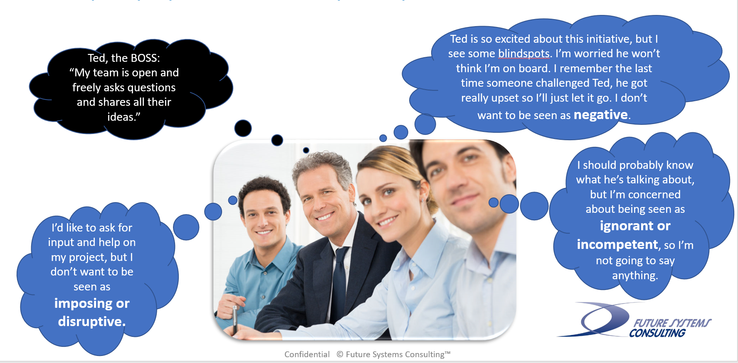
When you have high trust teams and organizations:
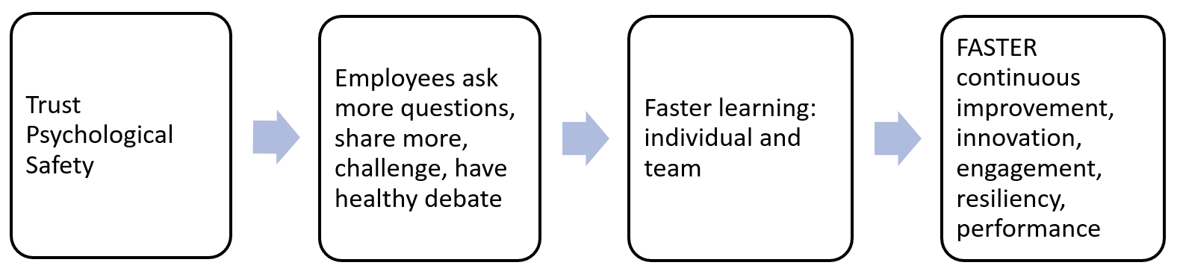
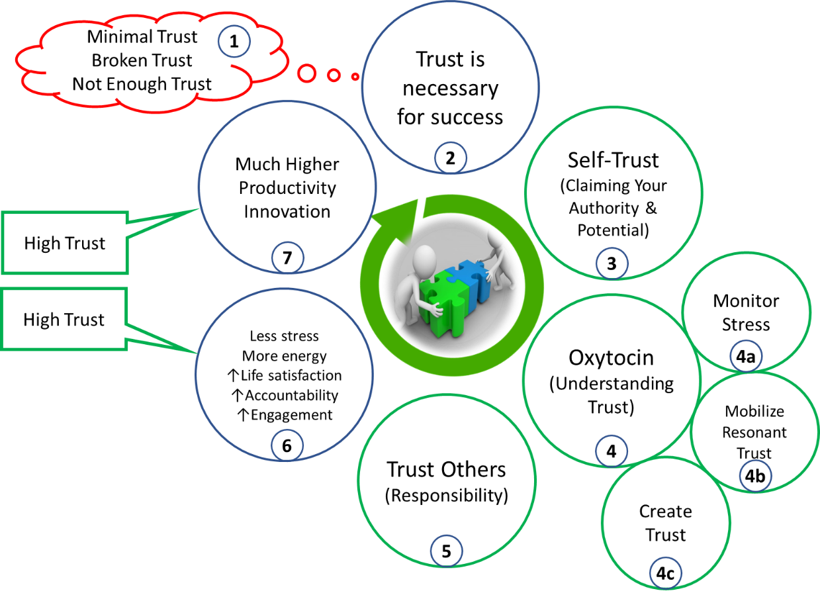
​Andy Hass, +1-763-670-6798, Andy@MyBreakthroughPerformance.com
​Rich Bents, +1-651-224-8525, rbents@FutureSystemsConsult.com
Richard Bents, PhD, and Andy Hass work for a small international consulting firm, Future Systems Consulting, with offices in St. Paul, Hamburg, Budapest, and Moscow. Founded in 1978, we empower the leaders of multinational companies through a comprehensive approach of leadership and systems-based organization development. Our relationships are data-driven, customer-focused, and value-based, with a focus on building leadership trust and empowerment. We offer several products and tools to assist individuals and organizations in the quest to harness the power of change for breakthrough performance. We leverage data, science, and experience, along with some humor and benevolence to empower leaders, teams and organizations. We only target and engage with exceptional companies, or those with exceptional aspirations. We look for companies with a leader that believes developing a high-trust organization will bring about the best in human potential and organizational performance in an increasingly distrustful and complex business and world environment.
From our client Groupama Insurance - Hungary, the largest insurance provider in Hungary. The organization faced a difficult future and in less than a year, successfully transformed sales and profitability in a competitive and declining insurance market. The top 86 executives were assessed, then went through a 7 month program. They exceeded their sales plans. The post-assessments showed statistical significant increases in all levels of trust. The following year showed increased market share and increased profit:
"I am very confident of the next steps. I already know that management skills development is a long road requiring patience, willingness and determination, and of course measurement. People are understanding what is happening now because they started experiencing that behaving differently is possible and can be a source of success.
As a 'rational' leader, we just have to admit that time to time it is worth investing much less in IT tools and process ...and a bit or much more in human potential." - Yann Menetrier, CEO, Groupama Hungary

